Linear Ordering Problem
Martí, Reinelt and Duarte (2009)
University of Valencia (Spain), University of Heidelberg (Germany) and University Rey Juan Carlos (Spain)
Problem Description
Let D_{n} = (V_{n}, A_{n}) denote the complete digraph on n nodes, where V_{n} is the set of nodes and A_{n} the set of arcs. A tournament T in A_{n} consists of a subset of arcs containing for every pair of nodes i and j either arc (i, j) or arc (j, i), but not both. T is an acyclic tournament if it does not contain any directed cycle. Obviously, an acyclic tournament induces an ordering < v_{i}1, v_{i}2,...,v_{i}n > of the nodes (and vice versa). Node v_{i}1 is the one with no entering arcs in T, v_{i}2 has exactly one entering arc, etc., and v_{i}n is the node with no outgoing arc. Given arc weights w_{ij} for every pair i, j in V_{n}, the linear ordering problem (lop) consists of finding an acyclic tournament T in A_{n} such that the sum of the weights of arcs in T is maximal, or in other words, of finding an ordering of the nodes such that the sum of the weights of the arcs compatible with this ordering is maximal.
Given an (n, n) matrix C = (c_{ij}) the triangulation problem is to determine a simultaneous permutation of the rows and columns of C such that the sum of superdiagonal entries becomes as large as possible (or equivalently, the sum of subdiagonal entries is as small as possible). Note, that it does not matter if diagonal entries are taken into account or not. Obviously, by setting arc weights w_{ij} = c_{ij} for the complete digraph D_{n}, the triangulation problem forC can be solved as linear ordering problem D_{n}. Conversely,a linear odering problem for D_{n} can be transformed to a triangulation problem for an (n, n) matrix C by setting c_{ij} = w_{ij} and the diagonal entries c_{ii} = 0 (or to arbitrary values).
The LOP can be formulated as 0/1 linear integer programming problem as follows. We use 0/1 variables x_{ij}, for (i, j) inA_{n}, stating whether arc (i, j) is present in the tournament or not. Taking into account that a tournament is acyclic if and only if it does not contain any dicycle of length 3, it is easily seen that the LOP can be formulated as the 0/1-IP.
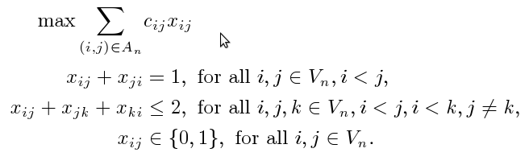

State of the Art Methods
The most relevant metaheuristics developed to solve this problem are:
- TS: Tabu Search. Laguna et al (1999)
- MA: Memetic Algorithm. Schiavinotto and Stützle (2004)
- VNS: Variable Neighbourhood Search. García et al (2006)
- SA: Simulated Annealing. Charon and Hudry (2007)
- SS: Scatter Search. Campos et al (2001)
- GRASP: Greedy ramdomized adaptive search procedure. Campos et al (2001)

Instances (LOLIB)
We have compiled a comprehensive set of benchmark problems including all problem instances which have so far been used for conducting computational experiments for the \lop. Furthermore we have included new instances. In their original definition, some problem instances are not in normal form. For the computations documented here, all problems have been transformed to normal form. We give a brief description of the origin and the characteristics of the groups of problems.
- Input/Output matrices: This is a well-known set of instances that contains 50 real-world linear ordering problems generated from input-output tables from various sources (Grötschel et al 1984). They are comparatively easy for nowadays metaheuristics and are thus more of interest for economists than for the assessment of approximate methods for hard problems. The original entries in these tables were not necessarily integral, but for \LOLIB\ they were scaled to integral values. Download.

